GASOC Travel Grant Report - The Mwezi Project, Uganda
Dr. Sadhbh Lee

I was very grateful to be a recipient of the 2025-26 GASOC Travel Grant. The grant supported me to continue my existing voluntary work with a sexual and reproductive health project in Uganda called The Mwezi Project. I was able to travel to Uganda for 2 weeks in October 2025 to visit the team there, during which I had the opportunity to organise and take part in a number of activities.

Background
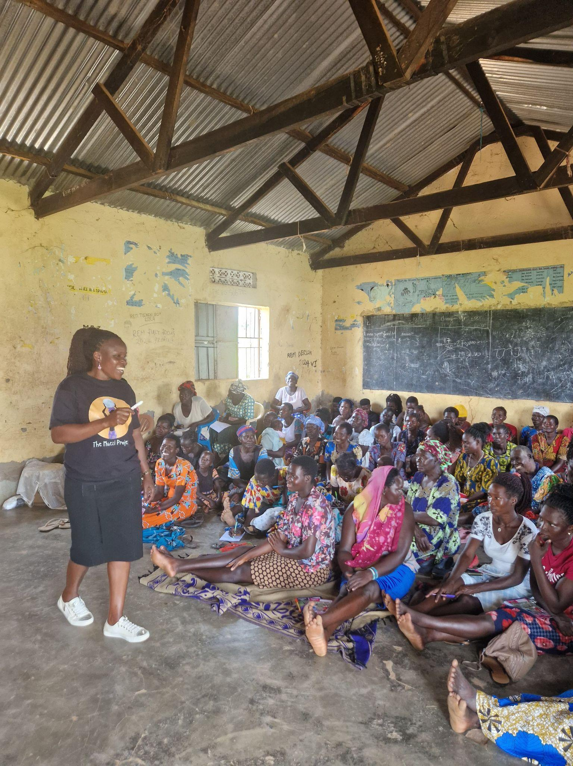
Women and girls in Uganda face many challenges to their sexual and reproductive health (SRH). As of 2024, the country has a maternal mortality ratio of 207 (1), much higher than the UN Sustainable Development Goals 2030 target of less than 70 (2). The rate of teenage pregnancy in Uganda is 25%, one of the highest in sub-Saharan Africa (3). Prolonged school closures in Uganda during the Covid-19 pandemic led to a rise in the number of teen pregnancies (4,5). HIV is acquired by 570 adolescent and young women in Uganda every week (6). Factors driving this rate include young age at first sexual experience, cross-generational sex, and lack of information about HIV prevention to inform healthy choices (6).

Following a 2016 parliamentary ban on CSE in schools, Uganda developed a National Sexuality Education Framework in 2018 (7). While covering many crucial topics of sexual and reproductive health, such as anatomy, gender-based violence, pregnancy prevention and menstrual hygiene, the content is centred around religious and cultural beliefs and does not mention condom use or contraceptives. These factors combined make sexual health education difficult to access in northern Uganda, particularly for rural communities.

In order to address some of these challenges, The Mwezi Project (TMP) was started in 2024. The mission of The Mwezi Project is to create a community where all individuals can make well-informed decisions on their sexual and reproductive health, where girls and women have autonomy and access to the sexual and reproductive health services they need, and where mutual respect between men and women prospers. Their focus of work is rural communities, who typically experience reduced access to sexual health education and services.

TMP delivers sexual health education and training to 5 rural communities in the Acholi region of northern Uganda. They provide reusable menstrual pads to women and girls and distribute condoms. They have also developed a network of community peer educators, empowering community members to become leaders in their own villages. In 2025, they shifted their focus of work to adolescent sexual health, running two main programs; sexual health education in primary schools and a support program for adolescent mothers. By working with other local organisations, such as Marie Stopes, they also assist rural communities to access SRH services.

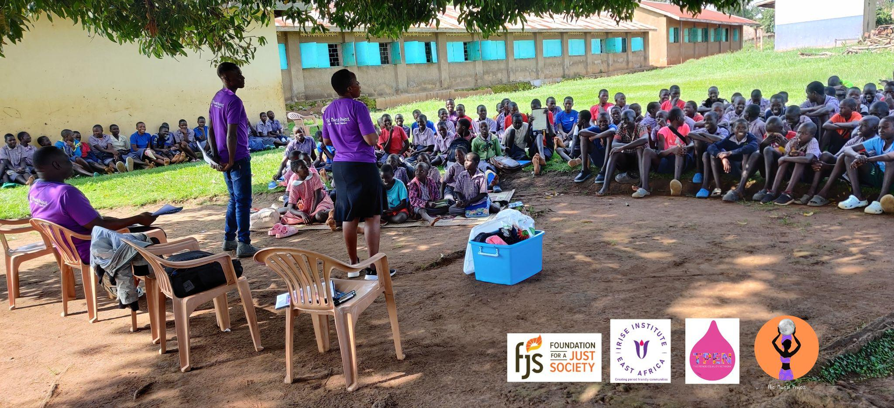

My role
Since 2024, I have been volunteering with TMP. My experience as an obstetrics and gynaecology doctor, as well as time spent working in the Acholi region in 2022, means I was well-placed to help the team develop a SRH education curriculum that was evidence-based but also considerate of the local cultural context. I provide regular training for staff members on SRH topics and support them for continued learning and capacity building. I also fundraise through collecting donations and organizing events.

My trip, October 18th-31st
July 2025 marked the start of TMP’s second year of operation and the commencement of their adolescent SRH program. With the expansion of activities, the team in Uganda were keen for some further training, capacity building and organisational support. Supported by the GASOC Travel Grant, I travelled to Uganda for two weeks in October to provide this support. I also had the opportunity to take part in some field activities.

- Training

I organised a teaching seminar with TMP’s two field officers, Mirriam and Mathew. We went through some general SRH topics and then focused specifically on adolescent SRH, exploring what the differences are both in the challenges adolescents face and the teaching approach required. While the team were very familiar with the adult education program, we spent some time on a new topic introduced in the adolescent program “My Body and Puberty”. Other topics included in the program are “Sexually Transmitted Infections”, “Menstrual Hygiene”, “Respect and Consent”, “Teenage Pregnancy” and “Family Planning”.

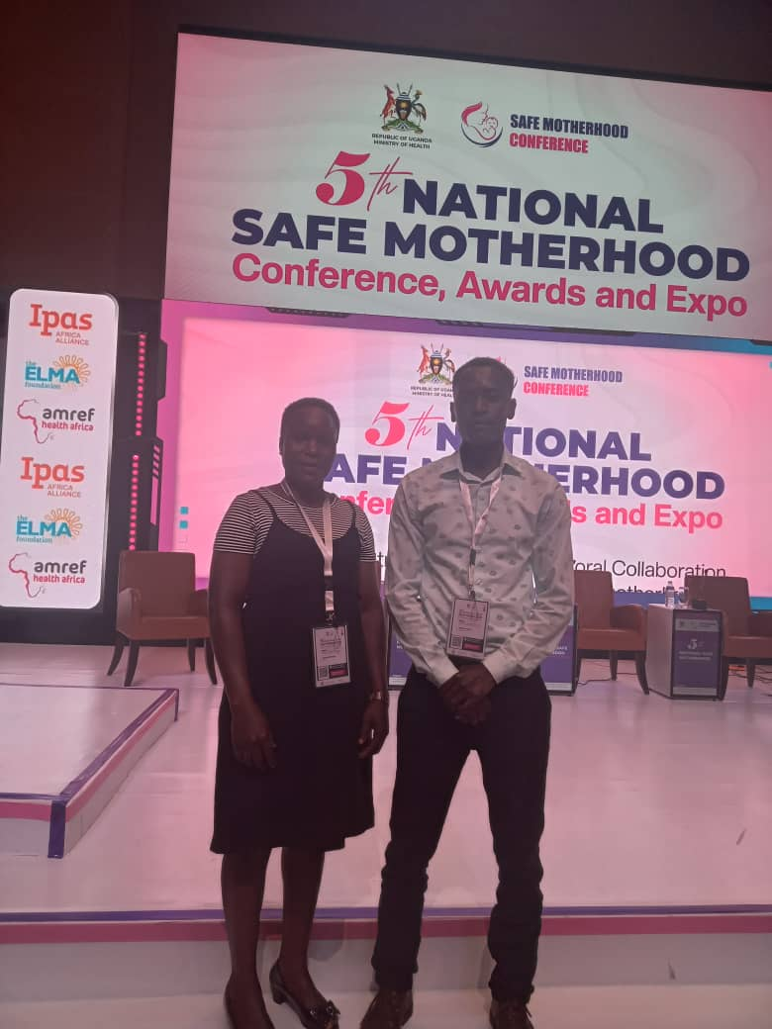
- Capacity building

From October 20th-22nd, the Ugandan National Safe Motherhood Conference took place in Kampala. I was able to facilitate the team to attend this conference, an annual event looking at maternal and neonatal outcomes in Uganda. However, a large portion of the conference also dealt with SRH and public health activities working at a grassroots level to address issues such as access to contraception. We had the chance to hear from other more established organisations working in the same area as TMP, who outlined challenges and successes to their work. It also provided a networking opportunity, allowing the team to connect with SRH organisations around the country. Attending the conference provided the team with technical knowledge, as well as a greater understanding of the national status of SRH in Uganda and how their work fits into that. They gained insight into the value of their work and the potential for growth and future successes.

- Organisational support

An area the team wants to improve on is their research, reporting and data collection. During my trip, I organised a meeting between TMP and the SRH Research Group from the local university, Gulu University. We met with three researcher-clinicians and one administrative officer to discuss how TMP and the SRH Research Group can collaborate on areas of mutual interest. The team from Gulu University agreed to provide support to the team on their data collection and reporting. They also agreed that Gulu University can be a base for acquiring ethical approval for any research TMP wishes to conduct, as well as providing expertise to help improve research and outcomes. The next step is for TMP to organize a presentation to the university team on their work and results so far.

- Field activities

My favourite part! During my trip, I joined the team for two field activities. Our first field visit took us to Lukodi Primary School, for the first session of the adolescent SRH education program in that school. Mathew and Mirriam took pupils from ages 12+ through the topic of “My Body and Puberty”. Prior to this session, they had also selected and trained 5 students as peer educators, who assisted in the teaching session, along with the senior woman teacher from Lukodi Primary School. It was fantastic to see the students engage in the activity and to observe the teen peer educators taking a leading role.

The school had also organised an activity with the younger students, who demonstrated to us hygienic use of toilet facilities, an important factor for menstrual hygiene.
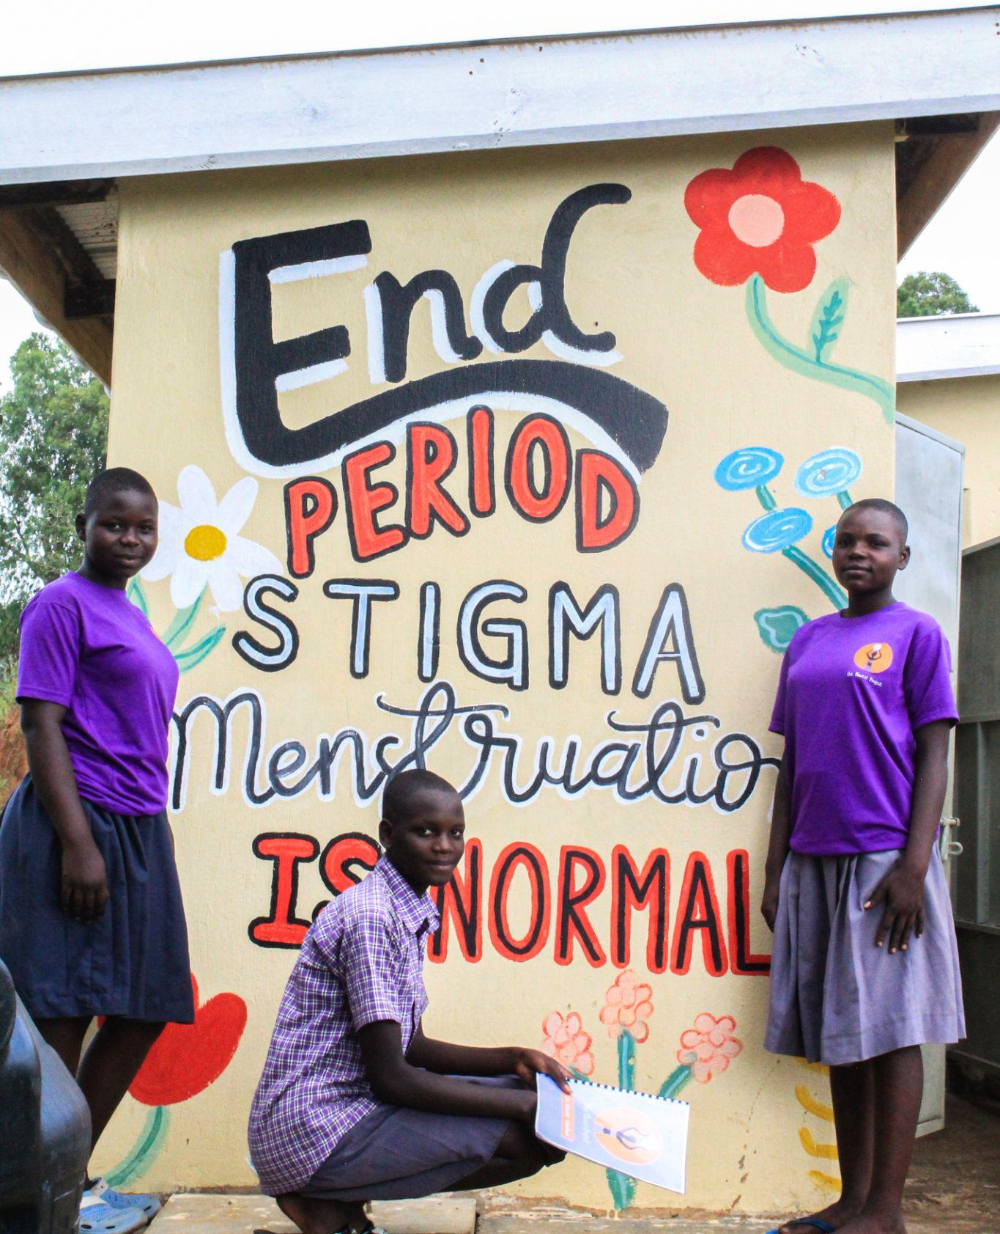

Student peer educators from Lukodi Primary School pictured with a mural at their toilet facilities

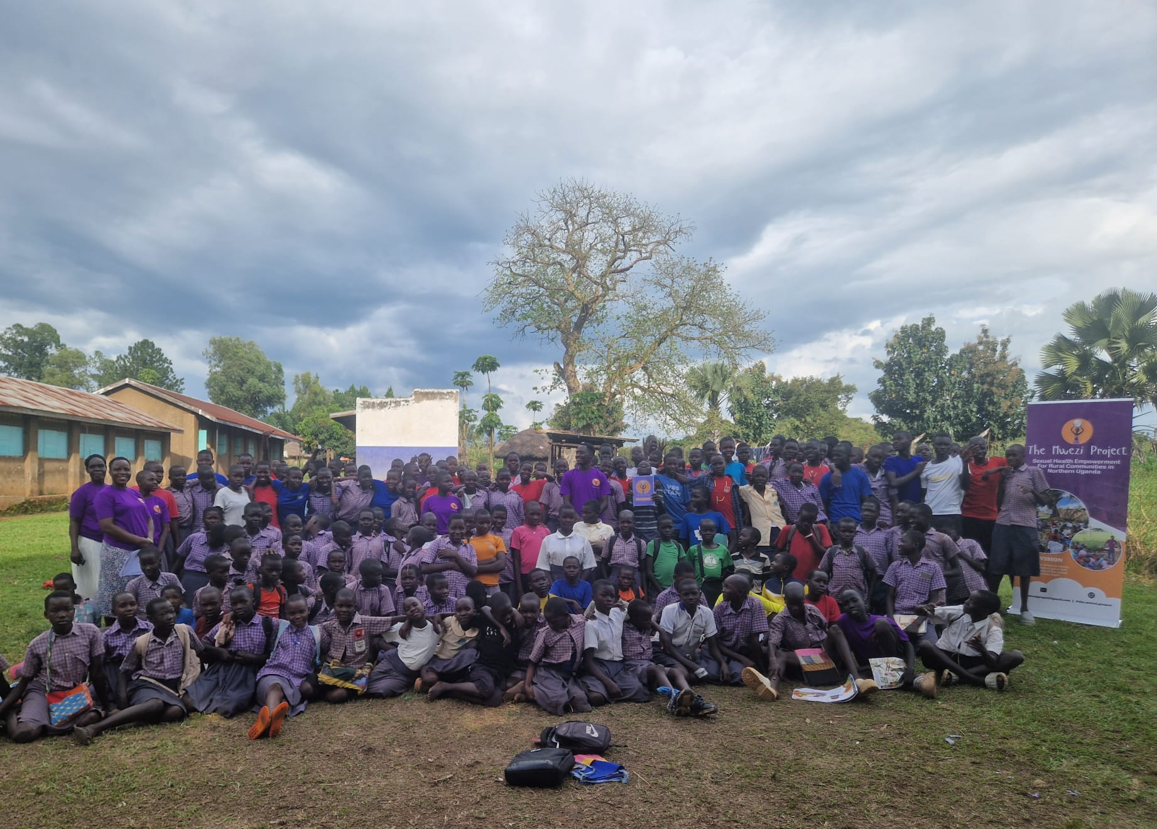

Our second field visit was to Ayilla Primary School, where the team had previously conducted the adolescent SRH education program. The students of the school had organised a creative showcase for TMP, based on the teaching they had received. A small group of students performed a poem discussing SRH topics, before a larger traditional dance performance.

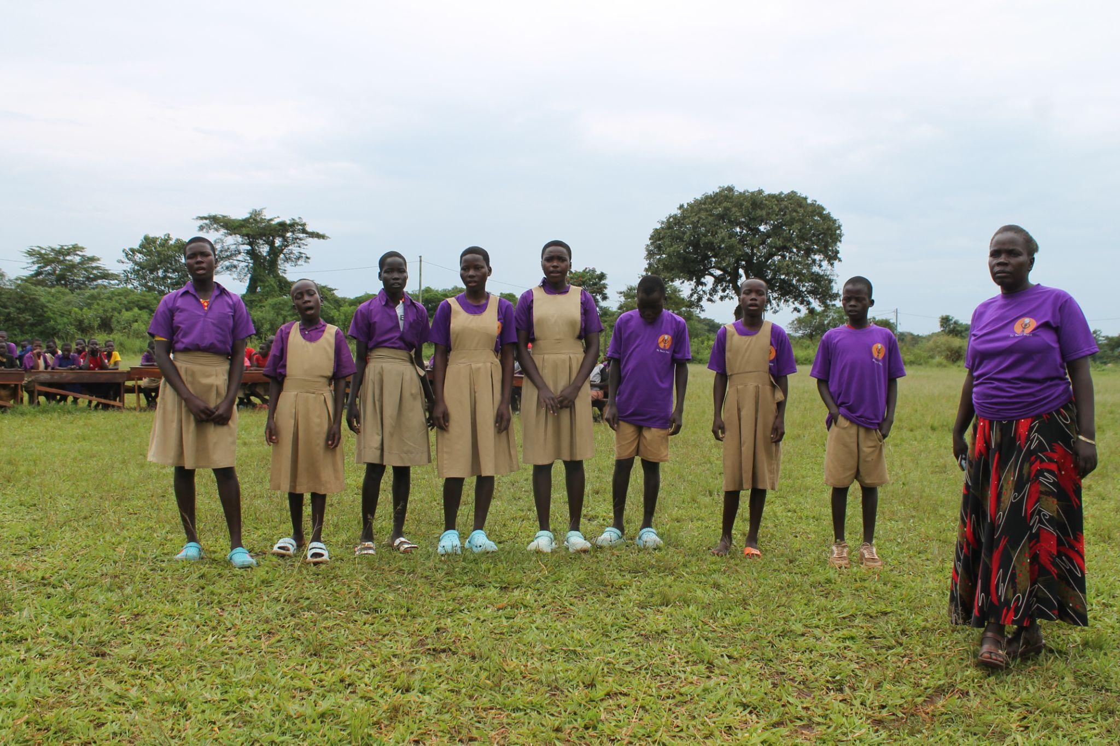

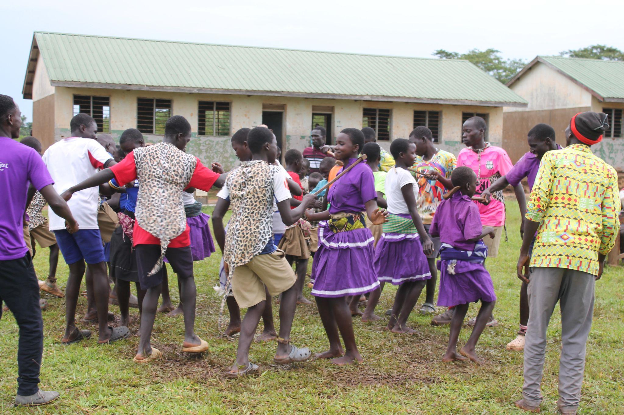

It was wonderful to see students translate their learnings into something creative, and to observe the energy and joy of the traditional dance.

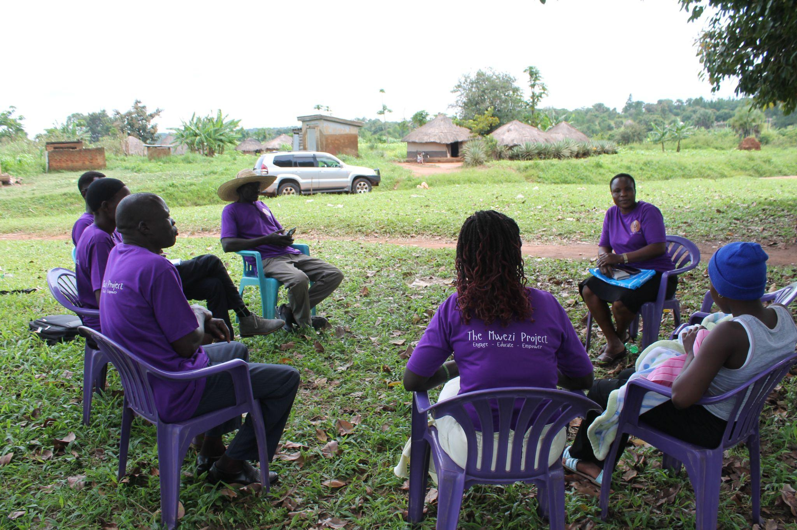
After the school visit, we met with the community peer educators. These are teams of 5 who work in their rural communities and report to Mirriam and Mathew monthly. They are responsible for delivering small basic SRH training, highlighting community needs and mobilising the community for any TMP activities. They also act as liaisons for the teenage mothers that TMP supports. We met with 3 teams to discuss the activities over the last month and hear about any challenges they faced. The peers reported general success of their work, though they face issues in reaching some of the more isolated members of their communities due to lack of transport means.

We also had the chance to meet with three of the teen mothers currently supported by TMP. These girls are all under the age of 16 and by the time of my visit, all had delivered. They had been referred to TMP earlier in their pregnancy, and TMP supported them by providing psychosocial support, family counselling and a delivery kit, pictured below.

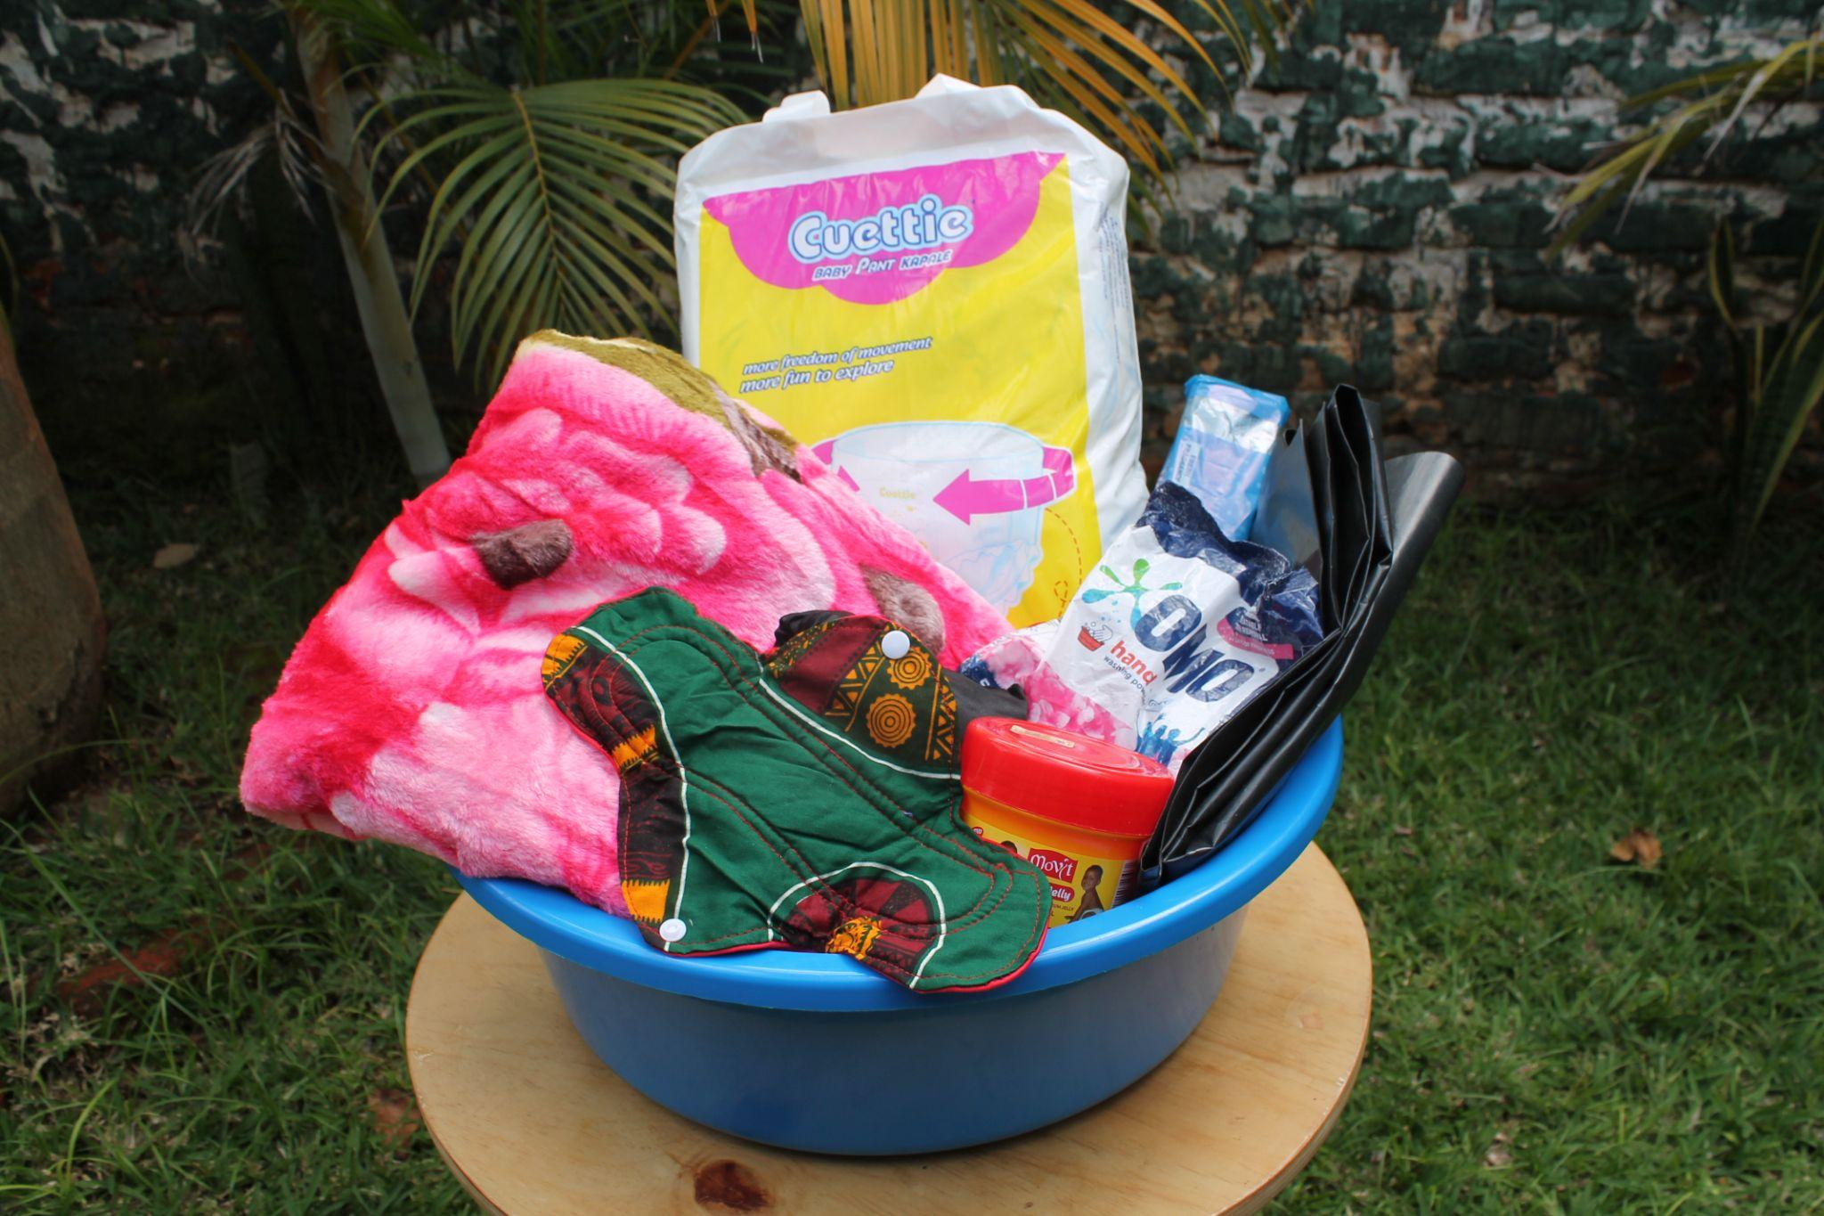

The next step in the support for these girls is to assist them with further education or training. Most of them do not wish to return to school, for social and financial reasons. Instead, they express a desire for vocational training, such as tailoring, so that they can support themselves and their new infants. TMP is working to provide them with such training, as well as counselling on contraception and the importance of avoiding a repeat pregnancy.

Overall, my trip was a very busy but successful one. I truly believe in the work of TMP and the dedication of the team to improving SRH for women, men, boys and girls in northern Uganda. I would like to take this opportunity to sincerely thank GASOC for providing me with the support for this trip. Apwoyo matek! (Thank you very much!)

References

- Government of Uganda National Population and Housing Census 2024 Final Report - Volume 1 (Main) [Internet]. 2024. Available from: https://www.ubos.org/wp-content/uploads/2024/12/National-Population-and-Housing-Census-2024-Final-Report-Volume-1-Main.pdf
- World Health Organisation. SDG Target 3.1 Maternal mortality [Internet]. www.who.int. 2023. Available from: https://www.who.int/data/gho/data/themes/topics/sdg-target-3-1-maternal-mortality
- Chemutai, V., W Musaba, M., Amongin, D. and N Wandabwa, J. (2022). Prevalence and factors associated with teenage pregnancy among parturients in Mbale Regional Referral Hospital: a cross sectional study. African Health Sciences, 22(2), pp.451–458.
- Alunyo, J.P., Mukunya, D., Napyo, A. et al. Effect of COVID-19 lock down on teenage pregnancies in Northern Uganda: an interrupted time series analysis. Reprod Health 20, 163 (2023). https://doi.org/10.1186/s12978-023-01707-8
- Otika D, Odongo G, Muzaki RMM, et al. Prevalence and factors associated with teenage pregnancy in refugee settlements of northern Uganda post-COVID-19 (2020–2023): a cross-sectional study. BMJ Open 2024;14:e089361. doi: 10.1136/bmjopen-2024-089361
- https://digitalcommons.unl.edu/cgi/viewcontent.cgi?article=11048&context=libphilprac
- Ministry of Education and Sports (2018). National Sexuality Education Framework 2018. [online] Republic of Uganda. Available at: https://s3-eu-west-1.amazonaws.com/s3.sourceafrica.net/documents/119376/UNFPA-68-090518.pdf.

